42U ENCLOSURE 19" CABINET 800X1200 FLOOR STANDING SERVER RACK - ECO NETCAB
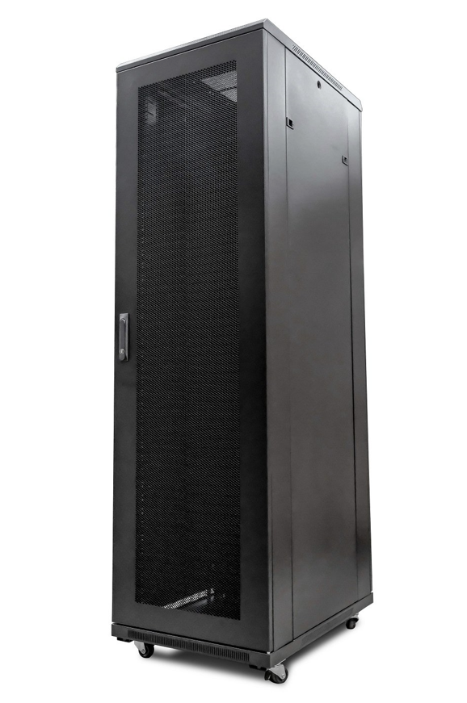

FEATURES
• 19"
• Colour : Black (Powder-coated RAL 9005)
• Dimensions:800x1200x2050mm (inc.castors)
• Up to 800Kg static load bearing
• Front mesh high venting door (lockable)
• Left/right hinged front/rear doors
• Removable side panels for easy access
• U-numbered uprights for rack-mount product alignment
• Multiple cable entry glands for exact power and cabling entry
• Fitted 4-way fan tray in raised and vented roof-space
• Fitted vented shelf
• Supplied with: Front Cable Management; Standard/Shipping Castors (Fitted): Set of 4 adjustable Jacking Feet (Supplied): Standard M6 Cage Nuts and Bolts (Supplied): Hex Adjusting Key (Supplied)

DOCUMENTS
Specification Sheet (PDF)

